Market Harborough Church of England Academy
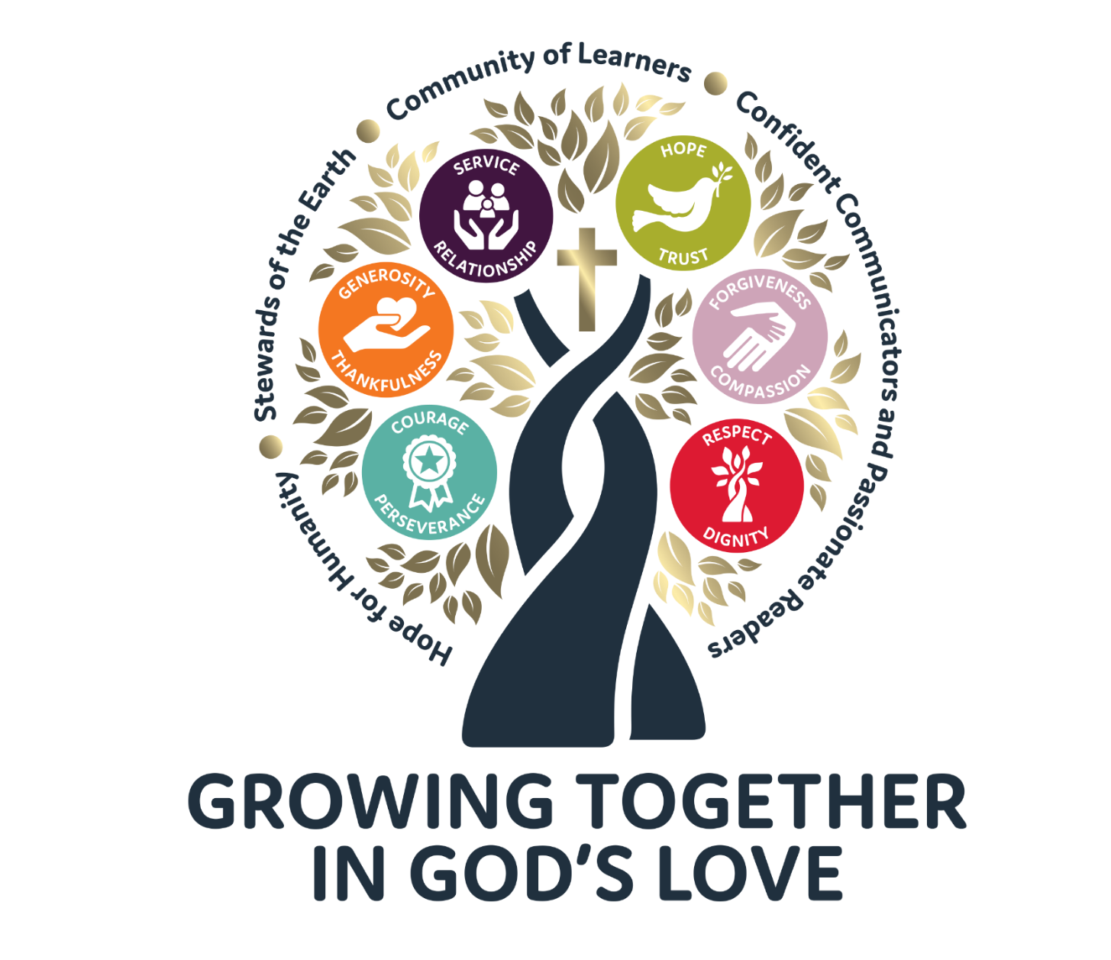

Mission Statement
Growing Together in God’s Love

Theologically rooted Chrisitan Message
When Jesus walked our earth, his message was revolutionary and transformative. He shared God’s message to mankind through love, acceptance, and forgiveness. Jesus emphasised the importance of loving God and loving one's neighbour as oneself. This is foundational to our mission statement ‘Growing Together in God’s love’.

Market Harborough CE Academy is a school with a heart. Our aim is to nurture those in our community and encourage children and staff to reach their full potential. Our vision statement ‘Growing Together in God’s Love’ our values and our golden threads reflect the caring ethos of our school. We are all growing, and we grow best in an environment where we feel special and valued for who we are. Where we are all noticed, known and cherished. We believe in the power of education to transform all our children’s life chances. What we teach them now will affect eternity as they take their place in our world.

In the Parable of the Mustard Seed “Jesus told the crowd ‘The kingdom of heaven is like a mustard seed. Someone took the seed and planted it in a field. It is the smallest of all seeds. But when it grows, it is the largest of all garden plants. It becomes a tree. Birds come and rest in its branches.’ Matthew 13:31-32 NIRV .

In our school, we are all seeds growing. Through our focus on growing in God’s love, we provide the foundations for each person [adult and child ] to flourish. We all start as small seeds with so much potential with us. As we nurture our pupils within a community where they are noticed and known, they blossom. They know they have a place, and they belong. As a school community, our aim is to cherish all those who walk through our doors and, in turn, encourage each of us to ‘love our neighbours as ourselves’. We nurture each child and provide the right conditions for growth through our expression of our school Chrisitan values and Golden Threads. As our pupils grow and mature, they bless our wider community. Just as the mustard seed becomes a tree and provides a home to many animals so our pupils provide compassion and kindness to others – showing what it looks like to love your neighbour. Through the care they show each other and our relentless focus on our school values and the work of our Golden Threads team – Hope for Humanity, Stewards of the Earth and Confident Communicators, our pupils are enabled to be a blessing to others. They reach out and care for others and our world. They become courageous advocates for Jesus’ radical message for mankind- love your neighbour as you love yourself.

Our desire is for every child to leave C of E with our school values engraved on their hearts - knowing that everyone is important and seeing their uniqueness as a gift. We want our children to know that they can make a difference to our world and be a hope for humanity, that they can provide love and light to their community and , in turn, help others to grow in God’s love too.

Our school is built on our mission, aims, our golden threads and our values.
These form the beating heart of our school and are central to all we aspire to be and do.
Golden Threads | Hope for Humanity  John 8:12  I am the light of the world. Whoever follows me will not walk in darkness but will have the light of life.
Golden Threads | Stewards of the Earth  Genesis 2:15  Treat the Earth as if your life depends on it.
Golden Threads | A Community of Learners  Proverbs 18:15  Wise men and women are always learning, always listening for fresh insights.
Golden Threads | Confident Communicators, passionate readers  Colossians 4:6  Let your conversation be gracious and attractive[a] so that you will have the right response for everyone.

Aims
- Successful, engaged learners who are knowledgeable, skilled, enjoy learning, make strong progress and achieve.
- Autonomous and empowered learners who take ownership of their learning and are proud of their achievements and are well prepared for life in modern Britain.
- Confident, articulate individuals who can lead safe, healthy and hopeful lives.
- Aspiring to ‘live life in all its fullness’ [John 10:10], knowing who they are and knowing their own self-worth.
- Aspiring to the very highest expectations of themselves and others, demonstrating the very best standards of conduct, moral purpose and integrity.
- Responsible citizens who are a hope for humanity at a local, national and global level.
- Respectful of themselves and others; developing an understanding of different cultures, faiths and the richness of the world we live in.
- Strong stewards of our world, recognising the interdependence of our world and its future sustainability.
- Outward facing; keen to serve our community; exemplifying ‘love your neighbour’.
- Inclusive; welcoming and cherishing everyone
We will achieve these aims by:

- Weaving our golden threads [ Hope for Humanity, Stewards of the Earth, A Community of Learners and Passionate Readers, Confident Communicators] and our values [Service and Relationships, Generosity and Thankfulness, Forgiveness and Compassion, Hope and Trust, Courage and Perseverance, Respect and Dignity] through the heart of our curriculum.
- Putting the Christian message of love and respect at the heart of all we do
- Providing a rich and exciting curriculum, both within and beyond the classroom which builds broad as well as subject specific knowledge, skills and learning behaviours over time.
- Being research engaged learning community providing structures which enable collaboration both within and beyond the school.
- Developing effective and high-quality professional development opportunities within a learning culture which maximises opportunities for teachers to learn from each other and provides support as well as challenge.
- Celebrating our own achievements and the achievements of others, recognising our own unique qualities and talents.
- Looking to Jesus as an example of leadership to emulate –supporting and challenging our community to be the best they can be. Holding each other to account and ensuring that breaking down barriers of disadvantaged is our guiding principle.
- Developing reflective leadership, using robust self-evaluation systems to consider the impact of our actions and carefully consider next steps.
- Developing children as autonomous learners and leaders in their own right.
- Relentlessly focus on developing our partnership with parents/carers, the wider community, the church and other schools.

As leaders in school, we will:

- Seek God’s direction by looking to Jesus as an example of Godly leadership and lead by his example.
- Be just and fair - do the right thing in the right way, with compassion and kindness.
- Encourage others to speak their minds, share sound counsel and listen to each other.; making sure goals benefit the school and community we serve. After all, “Without counsel plans fail, but with many advisers they succeed” (Proverbs 15:22).
- Always be learning, growing and developing. Proverbs 16:16 says, ‘How much better to get wisdom than gold’.
- Be humble. Proverbs 16:18: “Pride goes before destruction, and a haughty spirit before a fall.”
- Be respectful, valuing ALL the team by listing, valuing contributions, being compassionate and being generous whilst not being afraid to consider different views.
- Encourage others to grow and flourish as leaders.
- Be honest and dependable, conveying facts transparently and truthfully, no matter how unpopular they may be.
- Make decisions based on the values and golden threads of our organisation.

Christian Values
Our values are the beating heart of our school, guiding us in our everyday lives.
 | We will welcome everyone in our community.  We will look out for each other.  We will make time to serve others and never say 'it is not my job'.  THINK TOGETHER
 | We support each other.  We appreciate each other and say thank you.  We are grateful for all the many things we have.  THINK SHARE
 | We will help others who are having a difficult time.  We will try to let go of our hurts and forgive the mistakes of others.  We will try and stand in other people's shoes and understand them.  THINK LOVE
 | We try to look on the bright side of life and spread a message of hope for the future.  We know that being trustworthy shows you care.  THINK POSITIVE
 | We will keep going even when things are hard or don’t go our way.  We will be brave and stick at things even when they seem scary.  THINK STRENGTH
 | We are honest with each other but never humiliate.  We will treat others as we would like to be treated.  THINK VALUE
These values will guide the behaviour of all children and adults in our school.

With God’s help we:
- Respect ourselves, value others and our environment and show compassion in all we do.
- Build strong relationships based on good manners, trust, generosity and forgiveness.
- Follow instructions and always try our hardest even when we find things difficult.
- Think carefully about the choices we make and try to be wise and courageous.
- Will count our blessings and be grateful for the good things in our world and trust that as each day closes, we have been better people than we were the day before

Christian Values, theological background and biblical roots
Thankfulness  Being thankful is at the heart of Christian worship. Thanking God for giving and sustaining life. Seeing the world as God’s creation and knowing it is a gift and not a right.  Thessalonians 5:16-18  ‘Be joyful always; pray continually; give thanks in all circumstances, for this is God’s will for you in Christ Jesus.’ | Courage  Biblical courage is defined as the ability to do something brave out of a motivation of the heart. The Bible talks about what motivates the heart to produce courage.  Good courage always relies upon the supernatural power of God to strengthen and motivate believers to be courageous as children of God.  Deuteronomy 31:6  ‘Be strong and of good courage, do not fear nor be afraid of them; for the LORD your God, He is the One who goes with you. He will not leave you nor forsake you.’ | Respect  The word respect means “honour or value.” It literally means “to place a great value or high price on something.”  To respect everyone, believers must be conscious that God has created all people in His image, regardless of whether they believe in Christ. We should show them proper respect and honour because their souls are of more value than all the wealth in the world.  Philippians 2:3  ‘Do nothing out of selfish ambition or vain conceit. Rather, in humility value others above yourselves.’ | Hope  True hope is much more than a general idea that things will get better. It is more than a belief in progress, which sees the world and people as getting better all the time, Christian hope is grounded in the character of God. It is a hope rooted in the love and faithfulness of God. Hope is not wishful thinking but a firm assurance that God can be relied upon. The writer to the Hebrews describes the Christian hope as ‘an anchor for the soul, firm and secure’.  Jeremiah 29:11  ‘For I know the plans I have for you, declares the Lord, plans for good, to give you a future and a hope.’ | Helpfulness [serving others]  Words relating to ‘servant’ and ‘service’ are central in Christian theology. That is why Jesus said that he ‘came not to be served, but to serve.  The parable of the Good Samaritan shows we should help those in need whoever they are. ‘Going the extra mile’ involves sacrifice, putting ourselves out for someone else’s benefit.  Serving God means serving others.  Acts 20:35  ‘In all things I have shown you… we remember the words of the Lord Jesus, how he himself said, ‘It is more blessed to give than to receive.’ | Forgiveness  Forgiveness is fundamental to the character of God.  Jesus was uncompromising in his command to forgive. Forgive and keep on forgiving without limit. Forgiveness was at the heart of everything he did and is at the heart of the Lord’s Prayer. A prayer for the forgiveness of his persecutors was on Jesus’ lips as he died.  We forgive because we are forgiven. Forgiveness cannot be given or received unless it is asked for, and the asking must be genuine.  Ephesians 4:32  ‘Be compassionate and kind to one another, forgiving each other, just as in Christ God forgave you.’
Generosity  God was the first and is the most generous Giver of all.  He’s given us His generous love, generous acceptance and forgiveness.  Every moment we are alive is a gift from our generous Creator.  He went above and beyond anything we could have imagined.  God loved people so much that He gave. He gave His best. He gave His Son for you and for me. This act of generosity began in His heart first. He loved so He gave.  John 3:16  ‘For God so loved the world, as to give his only begotten Son; that whosoever believeth in him, may not perish, but may have life everlasting. ‘ | Perseverance  At its root, endurance is recognition that life is sometimes difficult and that it is important not to give up in the face of adversity. Perseverance is only possible where there is hope and that hope is based on the enduring nature of God’s love and faithfulness.  Colossians 1:11  ‘Being strengthened with all power according to his glorious might so that you may have great endurance and patience’ | Dignity  The image of God is a foundational concept for understanding our significance and purpose in life. Understanding how we are made in God’s image helps us understand our inherent dignity as a human being created by our heavenly Father.  Today, some Christians focus on our dignity and self-worth without much mention of our sinfulness. Others emphasize our utter unworthiness and sinfulness without much reminder of our dignity or God’s grace.  We should not focus on our sin for long without also noting God’s grace and our God-given dignity.  Psalm 139:13  ‘For you formed my inward parts; you knitted me together in my mother's womb.’ | Trust  Trust is the very essence of faith; trust in the God who is trustworthy. Time and time again, God is acknowledged as the source of all true security and strength. Trust is central to civilised society, to living together in harmony, so it is to be valued and honoured. Jesus entrusted his ongoing work to his disciples and ultimately to us.  Proverbs 3:5  Trust in the Lord with all your heart, and do not lean on your own understanding. | Relationship [friendship]  Relationships are key concepts in the Christian framework,  Jesus tells stories of the heavenly banquet to which all are invited. The barriers between people are broken down in a loving community around God and Jesus had stern words to say to those who refused to recognise that all are included in this community of friendship.  True friendship enables each person to grow and ensures that the unique individuality of each person is recognised. All this echoes the value placed by God on the preciousness of each person.  John 3:16-17  ‘For God so loved the world, that he gave his only Son, that whoever believes in him should not perish but have eternal life.’ | Compassion  ‘Compassion’ is stronger in meaning than simply ‘feeling sorry for’ someone. The words have their roots in the idea of ‘suffering with’ someone, putting yourself in someone else’s shoes. This leads to a desire to act, to do something. It requires an act of imagination and humility to share in the lives of others. Jesus showed compassion in all he did.  The father in the parable of the Prodigal Son [representing God] is not just forgiving. He is described as being filled with compassion.  1 Peter 3:8  Finally, all of you, live in harmony with one another; be sympathetic, love as brothers, be compassionate and humble.

